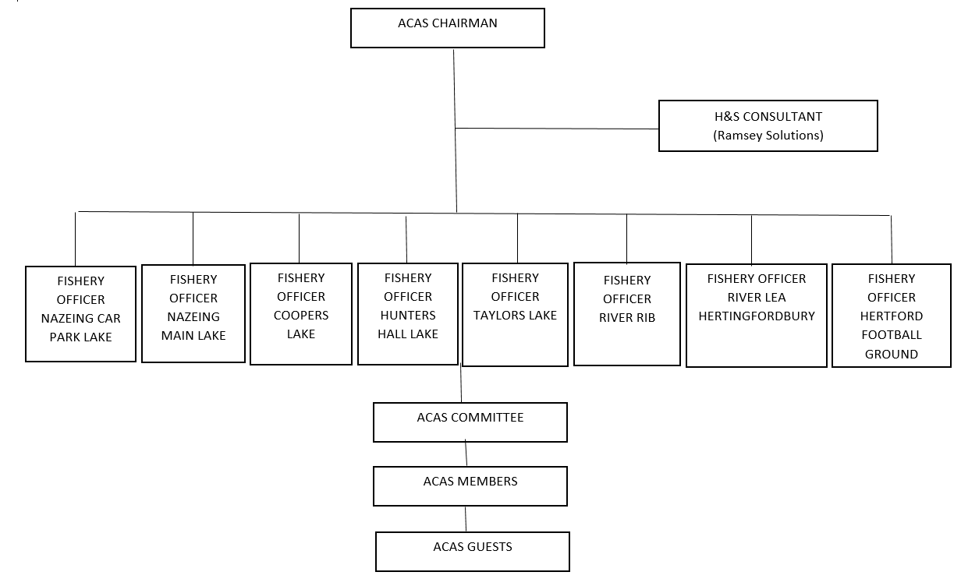

**Please see Addendum sheet for list of current Fishery Officers and their contact details**